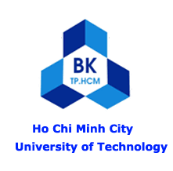

**HO CHI MINH CITY UNIVERSITY OF TECHNOLOGY**

**FACULTY OF CHEMICAL ENGINEERING**

268 Ly Thuong Kiet St., Dist. 10, Ho Chi Minh City, Vietnam

Tel: (848) 8650484 –Fax: (848) 8637504

# 

LETTER OF RECOMMENDATION

Assoc. Prof. **NGUYEN QUANG LONG**

Dean of Faculty of Chemical Engineering

Ho Chi Minh City University of Technology (HCMUT)- VNU HCM

## Tel: (848) 8650484 – Fax: (848) 8637504

Email: nqlong@hcmut.edu.vn

**Whom It May Concern,**

My name is Nguyen Quang Long. I am an Associate Professor and Dean of the Faculty of Chemical Engineering at Ho Chi Minh City University of Technology (HCMUT). It is my pleasure to offer my highest recommendation of Mr. Thanh Thien for admission to the University of Liverpool’s postgraduate programme. Over the past 10 years, I have written well over 30 letters of recommendation for both M.S. and Ph.D. candidates; Thien ranks among the very best.

I have known Thien for four years: first as his instructor in Physical Engineering (Fall 2020), and subsequently as his research advisor on two independent projects. From Fall 2021 to Spring 2022, he investigated reusable oxygen-sensor materials, and from Fall 2022 to Spring 2023, he developed a novel synthesis method of zeolite-based sorbent for CO₂ capture. Even as a sophomore, he proactively sought research opportunities - unlike most peers who wait until their senior year. In the lab, Thien consistently proposed innovative, critical solutions rather than waiting for guidance. He arrives fully prepared for both experimental challenges and collaborative discussions, making every session highly productive.

Thien’s dedication was most evident during the CO₂ adsorption project. With our system still in its infancy, he and his team independently sourced equipment, optimized protocols, and logged over 100 hours of nighttime experiments, significantly improving both adsorption capacity and contributing to the system’s new features. He documented every step with meticulous detail and continues to share these schematics and data with incoming students.

Beyond technical expertise, Thien excels in mentorship and teamwork. He informally trained new lab members in instrumentation and data analysis, freely sharing literature reviews and sample calculations. His professionalism and empathy foster a supportive environment that accelerates the entire group’s progress. Thien graduated with a 8.7/10 GPA. Although he plans to pivot toward Applied Artificial Intelligence in Computer Science - an unconventional path for a chemical engineer - his curiosity, resilience, and capacity for self-directed learning will ensure his success. In my experience, he ranks in the top 5% of all undergraduates I have taught in the past decade.

I give Thien my highest recommendation for your program. Please feel free to contact me if you require any further information.

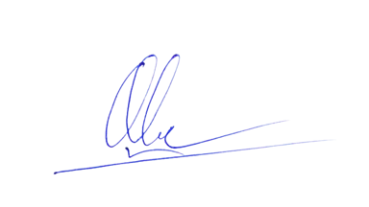

Sincerely,

**Nguyen Quang Long**